Program 1

Due Monday Feb 11 11:59 PM

Late Programs accepted until Wednesday, Feb 12 11:59 PM (-30 points)

# Decimal, Binary, and Hexadecimal

Numbers on the computer are represented using switches. If the switch is off, then the number is a zero. If the switch is on, then the number is a 1.

A number system that has only a zero digit and a one-digit is referred to as **binary**. You are used to using a **decimal** number system (some think this is because we have ten fingers).

A **hexadecimal** system, on the other hand, is one where there are 16 digits. Because we only have 10 numerals in our writing system, the numbers 10-15 are commonly represented as A thru F.

If you’ve ever done any web programming or messed around with Photoshop, you have probably been exposed to hexadecimal before. Colors are commonly represented with hexadecimal (hex for short) because the numerical representation is more compact than decimal and the hex representation splits up evenly into three parts (one for each of the reg, green, and blue color channels). In the example below, FF represents the red channel for the color *peach*, E0 represents the green channel, and B5 represents the blue channel.

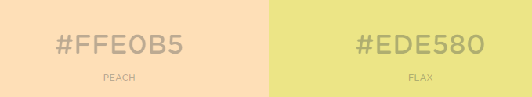

For more information on different number systems, check out the following link:

<https://www.mathsisfun.com/binary-decimal-hexadecimal.html>

One way to wrap your head around the different number systems is to line them up together in a table. The first 32 numbers are illustrated below:

|  |  |  |
| --- | --- | --- |
| Dec | Hex | Bin |
| 0 | 0 | 0 |
| 1 | 1 | 1 |
| 2 | 2 | 10 |
| 3 | 3 | 11 |
| 4 | 4 | 100 |
| 5 | 5 | 101 |
| 6 | 6 | 110 |
| 7 | 7 | 111 |
| 8 | 8 | 1000 |
| 9 | 9 | 1001 |
| 10 | a | 1010 |
| 11 | b | 1011 |
| 12 | c | 1100 |
| 13 | d | 1101 |
| 14 | e | 1110 |
| 15 | f | 1111 |
| 16 | 10 | 10000 |
| 17 | 11 | 10001 |
| 18 | 12 | 10010 |
| 19 | 13 | 10011 |
| 20 | 14 | 10100 |
| 21 | 15 | 10101 |
| 22 | 16 | 10110 |
| 23 | 17 | 10111 |
| 24 | 18 | 11000 |
| 25 | 19 | 11001 |
| 26 | 1a | 11010 |
| 27 | 1b | 11011 |
| 28 | 1c | 11100 |
| 29 | 1d | 11101 |
| 30 | 1e | 11110 |
| 31 | 1f | 11111 |
| 32 | 20 | 100000 |

You can convert from binary to decimal by using common algorithms. For example:

<https://www.wikihow.com/Convert-from-Binary-to-Decimal>

<https://www.wikihow.com/Convert-from-Decimal-to-Binary>

Similarly, there exist common algorithms for converting between hex and either decimal or binary:

<https://www.wikihow.com/Convert-Hexadecimal-to-Binary-or-Decimal>

# Implementation Details

You are to create a program that is driven by an input file. An example of a file driven program will be provided below. The first line of the file will contain the number of subsequent lines in the file. The subsequent lines in the file will be four pieces of information in each line:

1. The number representation being used in the line (B for binary, H for hex, D for decimal)
2. A first number (in the representation specified in 1)
3. An operand, either + or *, for addition or multiplication respectively
4. A second number (in the representation specified in 1)

For each of the lines, you are to output the result of the calculation **in the number system specified in (1)**.

For example, if the line is **D 123 + 456**, then you will print **579** to the screen.

If the line is B 101 + 101, then you will print **1010** to the screen (1010).

When implementing your program, you adhere to the following guidelines:

* You are allowed to use the <string> class to read in, for example, binary, decimal, and hex values. This will probably help you parse the individual values character by character.
* You may NOT use built in C++ conversion libraries such as stol, atoi, std::hex, etc. You MUST do the conversions yourself using for loops, multiply, divide, modulo, and any helper functions to convert between characters and integers.
* You must implement at least three functions
* Because the first line of the file is a number telling you how many lines to expect in the input file, you can use a loop to iterate over the inputs.

# Sample Input File

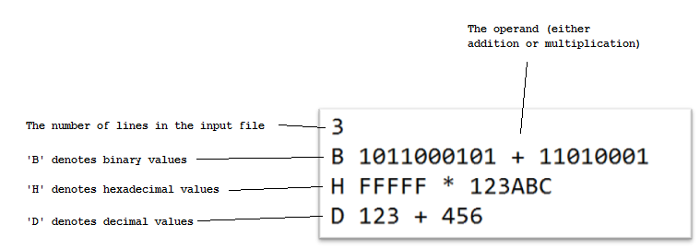

# Sample Output

1110010110

123ABADC544

579

# Submission Details

To canvas, you must turn in a file called **<LastName_FirstInitial>Program1.zip** containing your **program1.cpp** file, your **input text file**, your executable **program1.out** file.

# Example File Driven Program

The following file driven program can be used to help you read in a file line by line.

#include <iostream>

#include <fstream>

#include <string>

using namespace std;

int main(){

ifstream inFile;

int inputNumber; // note the use of "int"

string inputString; // note the use of "string"

inFile.open("my_input_file.txt");

if(!inFile.is_open()){

cout << "Could not open file." << endl;

return -1;

}

cout << "Reading first number in file..." << endl;

inFile >> inputNumber; // notice that the first item is

// a number, so we read into an int

cout << "We read the following number: " << inputNumber << endl;

cout << "Reading first string in file..." << endl;

inFile >> inputString; // notice that the second item is

// text, so we read into a string

cout << "We read the following text: " << inputString << endl;

cout << "Reading second string in file..." << endl;

inFile >> inputString; // notice that the third item is

// text, so we read into a string

cout << "We read the following text: " << inputString << endl;

// Close the file

inFile.close();

return 0;

}

The input file *my_input_file.txt* contains the following:

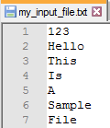

The program yields the following output:

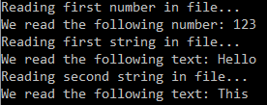

# Example Int to Char Program

When writing this program, you will probably need to understand that there is a difference between the character ‘1’ and the number 1. The computer will store the character ‘1’ as a sequence of 1’s and 0’s in memory. It just so happens that this sequence of 1’s and 0’s is equivalent to 00110001, which equals **49** in base 10. As such, you will need to be aware of this fact, and write code to accommodate the conversion between characters and numbers (and vice versa). The following sample program demonstrates converting between base 10 characters and base 10 integers.

#include <iostream>

#include <string>

using namespace std;

int CharToNum(char value){

// This function converts a character value into

// an integer, assuming the character is in

// the range of '0' to '9'

switch(value){

case '0':

return 0;

case '1':

return 1;

case '2':

return 2;

case '3':

return 3;

case '4':

return 4;

case '5':

return 5;

case '6':

return 6;

case '7':

return 7;

case '8':

return 8;

case '9':

return 9;

}

}

int main(){

string myNumber = "12345";

// loop over myNumber until we hit myNumber.length()

// printing out the individual numbers line by line

for(int i = 0; i < myNumber.length(); i++){

int x = myNumber[i]; // note that we are NOT doing a proper conversion from char to int

cout << x << endl;

}

cout << endl;

for(int i = 0; i < myNumber.length(); i++){

int x = CharToNum(myNumber[i]); // now we are using a helper function to do the appropriate conversion

cout << x << endl;

}

cout << endl;

return 0;

}

Output:

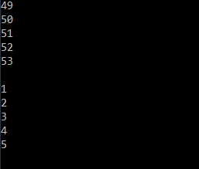

# Example Use of Modulo and pow

The modulo operator (%) and the pow function are two handy tools to use when manipulating numbers.

Modulo (or mod) returns the remainder of a division.

For example:

3 / 2 = 1.5, or, 1 with a remainder of 1.

4 / 2 = 2.0, or 2 with a remainder of 0.

5 / 2 = 2.5, or 2 with a remainder of 1.

And so on…

The pow function is simply the way to perform and exponential operation, x ^ y, in c++.

#include <iostream>

#include <math.h> // contains the pow function

using namespace std;

int main(){

int myValue = 15;

cout << "myValue % 2: " << myValue % 2 << endl;

cout << "myValue % 10: " << myValue % 10 << endl;

cout << "myValue % 16: " << myValue % 16 << endl;

double result = pow(10,2); // note that pow returns a DOUBLE, not an INT

cout << "10 ^ 2: " << result << endl;

return 0;

}

Output:

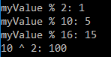

# Example Use of **long long int**

Different data types use a different amount of 1’s and 0’s to represent the number.

For example, on a 32 bit system, an integer is represented with 32 bits. This means that the maximum value for an integer is 231-1 = 2,147,483,647 (the first bit is used to control if the integer is positive or negative), so it’s 231-1 and not 232-1.

The effect of this limitation is that if an integer gets too large, the processor will flip the first bit and make the number appear negative.

A way to avoid this problem is to use a data type that has a greater amount of 1’s and 0’s. For example, the data type **long long int** on the same 32-bit system will have a max value of 263-1.

See below for an example of creating a number too large to be represented by an int, but is earily represented by a **long long int**.

#include <iostream>

using namespace std;

int main(){

// The largest value for INT is 2,147,483,647

int num1 = 1000000000; // 1,000,000,000

int num2 = 1000000000; // 1,000,000,000

int num3 = num1 * num2; // Should be 1,000,000,000,000,000,000

cout << "Num3 as INT: " << num3 << endl;

long long int num4 = 1000000000; // 1,000,000,000

long long int num5 = 1000000000; // 1,000,000,000

long long int num6 = num4 * num5; // Should be 1,000,000,000,000,000,000

cout << "Num6 as LONG LONG INT: " << num6 << endl;

return 0;

}

Output:



# Reversing a String

When building this program, you may find it useful to reverse strings. There is a *reverse* algorithm located in the *algorithm* library.

The program below shows you how you can reverse a string, as well as append characters to a string and then do a reversal.

#include <iostream>

#include <string>

#include <algorithm> // contains the 'reverse' algorithm

using namespace std;

int main(){

string mySentence = "This is a sentence.";

cout << mySentence << endl;

reverse(mySentence.begin(), mySentence.end()); // reverse the string

cout << mySentence << endl;

cout << endl;

string myNumberAsString = "";

// append characters to string

myNumberAsString += '1';

myNumberAsString += '2';

myNumberAsString += '3'; // the string is now "123"

cout << myNumberAsString << endl;

reverse(myNumberAsString.begin(), myNumberAsString.end()); // reverse

cout << myNumberAsString << endl;

cout << endl;

return 0;

}

Output:

